**Step Up Your Shoe Organization Game: Choose the right one** 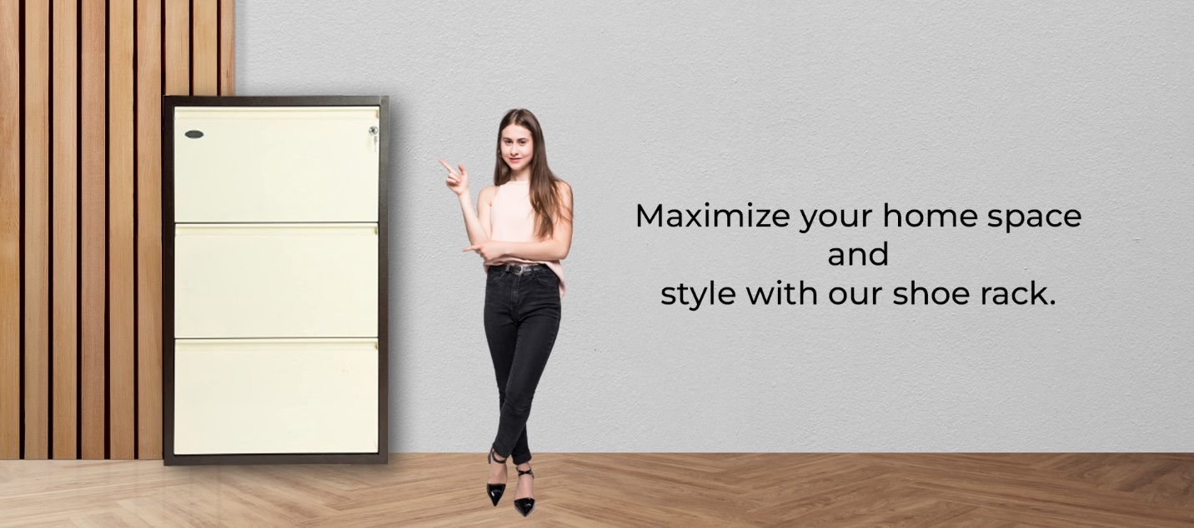

Are you exhausted from tripping over your shoes each time you walk through the door? Do you find yourself constantly searching for the matching pair in a pile of footwear? If so, it may be time to invest in a shoe rack. Not only will it help you organize your shoes, but it can also add an extra element of Style to your entryway or closet. In this post, we'll discuss the benefits of a shoe rack and how to choose the right one for your needs.

**What are the benefits of having a shoe rack?**

**a. Organization**

By keeping your shoes in a designated spot, you'll never have to search for the matching pair again. Plus, it'll help keep your floors clean and free of clutter.

**b. Helps keep your shoes safe**

A shoe rack can also help extend the life of your shoes. When shoes are piled on top of each other or thrown haphazardly into a closet, they can become damaged or misshapen. By keeping them on a rack, you'll be able to see all of your shoes at once and easily select the ones you want to wear without damaging them.

**c. Saves time**

With all of your shoes in one place, you won't have to invest time in searching for the ones you need. Plus, if you have a large collection of shoes, a shoe rack can help you keep track of them all.

**How to choose the right shoe rack?**

Consider these things when choosing the right shoe rack:

**a. The right size**

How many shoes do you have? Make sure you choose a shoe rack to accommodate all your footwear.

**b. Style of the rack**

Do you want your shoe rack to blend in with your decor, or do you want it to make a statement? Shoe racks are available in a variety of styles, from classic wooden racks to modern metal ones.

**c. Functionality**

Do you need a shoe rack with additional storage for other items, like umbrellas or hats? Do you want a shoe rack with adjustable shelves? Think about how you will use your shoe rack and choose one that fits your needs.

**d. Durability**

Make sure you choose a shoe rack that is made from sturdy materials that can withstand daily wear and tear.

**Shoe rack at Equal**

Made up of heavy-duty mild steel sheets with rustproof coating, our shoe rack is the perfect addition to your house. It has ventilation holes that keep the rack from odor and humidity. The weight is 23.50kg and can easily hold up to 12-16 pairs of shoes. To add to it, it comes with a gorgeous brown color with the perfect style to please your home.

**Conclusion**

Investing in a shoe rack is a great way to keep your footwear organized, extend the life of your shoes, and save time. When choosing a shoe rack, consider the size, Style, Functionality, and Durability to find one that fits your needs. With the right shoe rack, you'll never have to search for the matching pair again!